Trailfire :
You Want Me to Follow What?

For our solar system unit we are going to follow a Trail within a Trailfire. What is this you might ask, good question! A Trailfire is a series of complimentary websites that are tagged and strung together.

Before we follow the Trail for our solar system I have put together a quick tutorial Trailfire that has a Trail for you to follow. Below you will find some helpful hints to guide you how to follow the Trail successfully. Happy hiking!

To begin your Trailfire go to the website:http://www.trailfire.com/spheet/trails/59381



- This is the image you will see when you get to your first stop on the Trail. Place your cursor over the Trailfire Tag and read the directions on what to do.

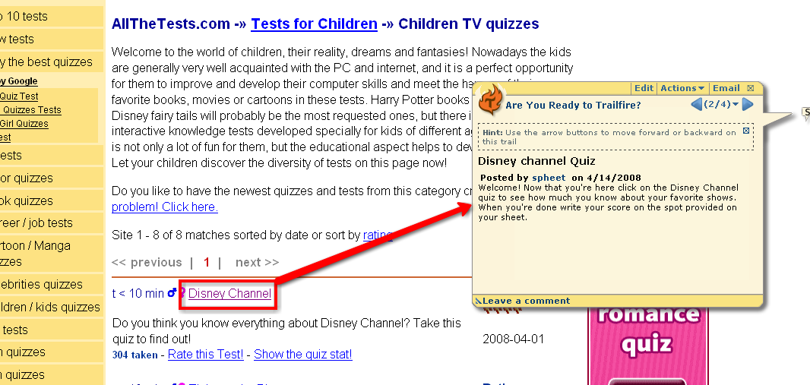

- Occasionally you will be asked to follow a link to another place within the website. When you have to do this be sure to click the back arrow button to get back to the spot on the Trail that has the Tag.

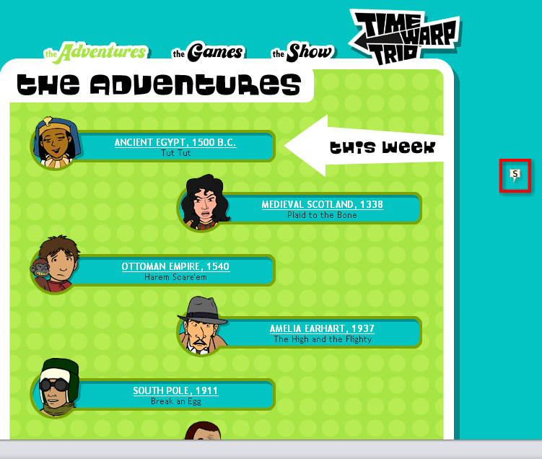
- If you ever arrive at a spot on the Trail and the comment box doesn’t open, click on the Tag to open it.


- Pay close attention to the directions within the Trail. You may have to answer a question, do an activity, or record a score.

Answer Sheet

- Record your score from the Disney quiz here____________________________________

- Record your answer from the Time Warp Trio page here__________________________

- Record your score from the math game here___________________________________

